Year 12 ATAR PHYSICS

Unit 4

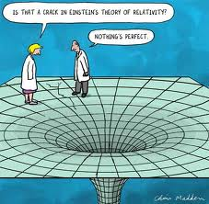

Special Relativity

Observations of objects travelling at very high speeds cannot be explained by Newtonian physics. These include the dilated half-life of high-speed muons created in the upper atmosphere, and the momentum of high-speed particles in particle accelerators.

- The muon (from the Greek letter mu, μ) is an elementary particle similar to the electron, but with a much greater mass.
- Muons are formed when cosmic radiation impacts air molecules 10 km up in the Earth’s atmosphere. About 10 000 muons reach every square meter of the Earth’s surface every minute.

- The mean lifetime of a stationary muon is 2.2 x 10⁻⁶ seconds before it decays.
- Muons travel at speeds of up to 0.999c.
- Because of their very short lifetime, they would be expected to only travel about 600 m.
- However, it has been found that they can penetrate deep into rock and they are detectable deep underground and underwater.
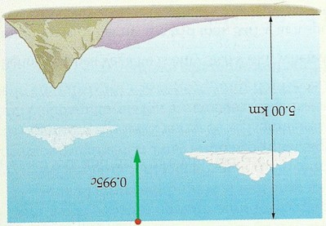
- Newtonian physics could not explain this.

- If a muon is produced 5.00 km above Earth and is travelling at 0.995 c, how far will it travel if it lasts 2.2 x 10⁻⁶ according to Newtonian calculations?

- At high speeds (close to the speed of light) calculations become complicated.
- Rossi and Hall in 1940 were able to “prove” the effect of time dilation on high speed muons. They measured muon impacts on a scintillation counter at an altitude of 3000 metres (568 counts h⁻¹) and at sea level (412 counts h⁻¹).

- A particle accelerator is a machine that uses electric fields to propel charged particles to nearly light speed and to contain them in well-defined beams.
- Large accelerators are used in particle physics as colliders (e.g. the LHC at CERN, or as synchrotron light sources for the study of condensed matter physics.
- Smaller particle accelerators are used in a wide variety of applications, including particle therapy for oncological purposes, radioisotope production for medical diagnostics, ion implanters for manufacture of semiconductors, and accelerator mass spectrometers for measurements of rare isotopes such as radiocarbon.

- In the design of particle accelerators, physicists need to consider the relativistic effects of high speeds on particles.
- Time, distance, mass and energy calculations all change at high speed, compared to low speed Newtonian calculations.

- The momentum of a particle is normally calculated from p = mv.
- However, it has been shown that as particles approach the speed of light, their mass (and therefore their momentum) increases substantially.
- A particle travelling at c will have infinite mass and infinite momentum.
- As this is impossible, this is one reason why particles cannot travel at the speed of light. )nly massless materials (like photons) can travel at the speed of light.

- GPS satellites move at high speeds ~ 14 000 km hr⁻¹ (0.02% c). Clocks on these satellites would be affected by ‘time dilation’ and distances will not be accurate. Algorithms built into the processing units on the satellites compensate for this time dilation.

Einstein’s special theory of relativity predicts significantly different results to those of Newtonian physics for velocities approaching the speed of light.

Principle of Relativity and Galileo

- Consider the example of a person running backwards on a train at the same speed the train is moving forward, say at 5.0 m s⁻¹. Two people observe this runner each from their own frame of reference.

A


5.0 ms⁻¹
5.0 ms⁻¹


B

- Person A, standing at the front of the train, will see the runner move away from them at 5.0 m s⁻¹.

- Person B however, is standing on a platform watching the train go by and to him the runner is not moving.

- The motion of the runner is relative to the position of the observer; to their own different frame of reference.

- Relativity began with Galileo, who said that, in the laws of mechanics, only relative motion is important.

- In other words, mechanical forces are the same for the person on the train and the platform. They simply need to add or subtract the relative velocities to convert their measurements and then obtain the same mechanical forces.
http://www.phys.unsw.edu.au/einsteinlight/jw/module1_Galileo_and_Newton.htm
(MODULE 1)
http://www.phys.unsw.edu.au/einsteinlight/

Einstein’s Special Theory Of Relativity

- Einstein's Special Theory of Relativity describes the motion of particles moving at close to the speed of light.
- This doesn't mean Newton was wrong – his equations are contained within equations relating to relativity.

- Newton's "laws" provide a very good approximate form, valid when v is much less than c.

- For particles moving at slow speeds (very much less than the speed of light), the differences between Einstein's laws of motion and those derived by Newton are minute.

- That is why relativity doesn't play a large role in everyday life.

- Einstein's theory supersedes Newton's, but Newton's theory provides a very good approximation for objects moving at everyday speeds and hence their use in physics in senior schooling.
(MODULE 2,3)
http://www.phys.unsw.edu.au/einsteinlight/
The special theory of relativity is based on two postulates: that the speed of light in a vacuum is an absolute constant, and that all inertial reference frames are equivalent

Theoretical Basis for Special Relativity

- The first postulate states that the speed of light is the same for all observers, no matter what their relative speeds.
S
E
E

- The speed of light will be seen to be the same relative to any observer and therefore
independent of the motion of the observer.

- In 1887, Michelson and Morley completed their interferometer experiment. An
interferometer is able to detect tiny shifts in the speed of light as condition changed.

- They set about measuring the speed of light from a distant star as the
Earth moved towards the Sun and then away from it.
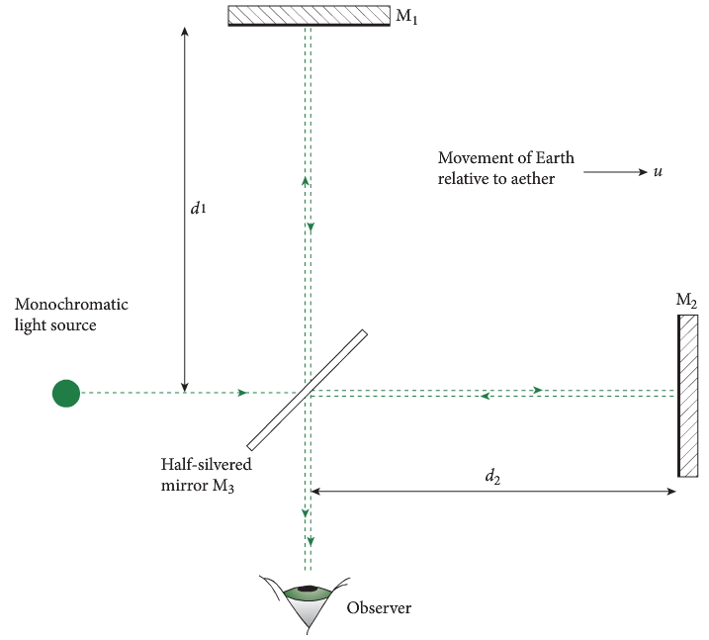

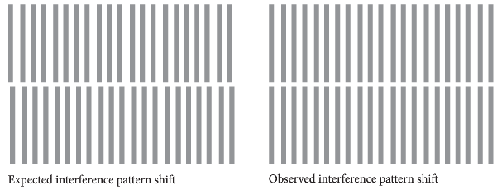

- This resulted in no significant difference.

- This is the crucial idea that led Einstein to formulate his theory. It means we can define a quantity c, the speed of light, which is a fundamental constant of nature.

- The speed of light is always the same, regardless of whether the measuring instrument is moving or not.

- Note that this is quite different from the motion of ordinary, massive objects.

- Imagine you are driving down the freeway at 90 kilometres per hour relative to the road, a car travelling in the same direction at 100 kmhr⁻¹ has a speed of only 10 kmhr⁻¹ relative to you, while a car coming in the opposite direction at 100 kmhr⁻¹ approaches you at a rate of 190 kmhr⁻¹. Their speed relative to you depends on your motion as well as on theirs.
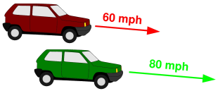
90 kmhr⁻¹

100 kmhr⁻¹

100 kmhr⁻¹

- The second postulate states that the laws of physics are the same in any inertial (that is, non-accelerated) frame of reference.

- This means that the laws of physics observed by a hypothetical observer travelling with a relativistic particle must be the same as those observed by an observer who is stationary.

- This second postulate is really a basic though unspoken assumption in all of science.

- It is the idea that we can formulate rules of nature which do not depend on our particular observing situation.

PP 8.1 p 304-14 8.1 Review p 315-6

Lorentz Transformation
Motion can only be measured relative to an observer; length and time are relative quantities that depend on the observer’s frame of reference
This includes applying the relationships

- Lorentz transformation is the result of attempts to explain how the speed of light was observed to be independent of the frame of reference of the observer.

- The transformations describe how measurements of space and time by two observers are related.

- Observers moving at different velocities may measure different distances, times and even order of events

Consequences of the Special Theory of Relativity

- Einstein said that all of the consequences of special relativity can be derived from examination of the Lorentz transformations.

- These transformations, and hence special relativity, lead to different physical predictions than that of Newtonian mechanics.

- These transformations occur when relative velocities become comparable to the speed of light.

- Time dilation:
  - The time elapsed between two events can be measured differently from one observer to another and is dependent on the relative speeds of the observers' reference frames.
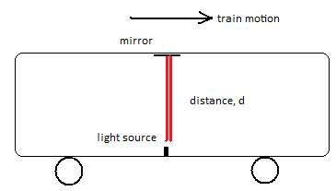
  - A train is moving at a velocity close to the speed of light.

  - A light beam is sent from the floor to a mirror on a roof of a train carriage and timed so that the velocity of light can be measured.
  - To the observer on board, the light is seen to travel straight upward and downward as shown along the same path.
  - He uses the expression, v = s/t, and successfully obtains the velocity of light, c.
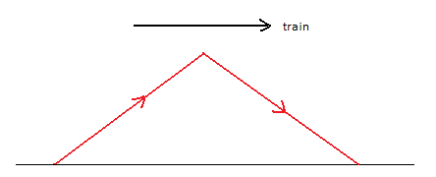
  - However, an individual is standing on the ground outside the train and watches this experiment take place.
  - This person also times and measures, the distance d moved by the light.
  - To her, the light has taken a differing path, due to the movement of the train.

  - She also finds v = s/t, with a longer distance and amazingly obtains the same true value for the velocity of light.
  - According to Michelson and Morley, both experimenters must obtain the same measurement of the velocity of light.
  - This can only happen if time on the moving carriage has become a larger value as well.
  - That is, time has dilated or slowed down, as observed by the stationary person.
  - Clocks on board the train are seen to be running slow and the traveller is aging more slowly than the stationary observer.
  - The degree of time dilation becomes greater as the train goes faster with time stopping if the speed of light is finally reached.
  - To the traveller though, all seems normal inside while he moves at near light velocity, but amazingly, sees time dilating for the stationary observer as well.

- The equation $t= \frac{t_{0}}{\sqrt{1-\frac{v^{2}}{c^{2}}}}$ is used. t₀ is the time according to the observer in the moving object.

  - t₀ = proper time (from the traveller’s p.o.v.)
(MODULE 4)
http://www.phys.unsw.edu.au/einsteinlight/

  - The twin paradox concerns a twin who flies off in a spaceship travelling near the speed of light and returns to discover that his or her twin sibling has aged much more.

  - The relationship between time dilation and relative speed is shown in this curve. (As seen by a stationary observer)
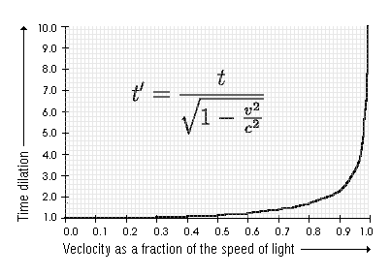

- Adelle and Elizabeth are twins. Adelle sets of on an adventure that takes her to a distant stellar system and returns. The average speed of Adelle’s ship is 0.60 c. Elizabeth remains on Earth. When Adelle returns, Elizabeth has aged 20 years. How much has Adelle aged according to her spacewatch?

- Why is this a paradox?

- Global Positioning Satellites (GPS) are affected by time dilation, ~ –7 μs per day, and by the Earth’s gravity, ~ +45 μs per day; a gain of ~ +38 μs per day. Clocks on the satellites need to be adjusted to cater for this.

PP 8.2 p 317-23 8.2 Review p 324

- Relativity of simultaneity:
  - Two events happening in two different locations that occur simultaneously in the reference frame of one inertial observer may not occur simultaneously in the reference frame of another inertial observer.
  - Consider the following situation – a train travelling at a velocity at close to the speed of light is struck at the front and back of carriage.


A
B
A
B

From the point of view of a From the point of view of a person outside
person inside the carriage, the the carriage, the time that it takes for the
time that it takes for the light to light to reach him from B will be less than
reach him from A and B will be from A since the carriage is moving to the right
the same. and the light travels a shorter distance

A
B


B
A


A
B


B
A


A
B


B
A

The strikes would be considered The strikes not would not be considered
to be simultaneous. to be simultaneous.
- Length contraction: The dimensions (e.g. length) of an object as measured by one observer may be smaller than the results of measurements of the same object made by another observer.
  - Distances or lengths in the same dimension (or direction) of the reference frame velocity, contract (reaching zero at the velocity of light), according to the stationary observer.
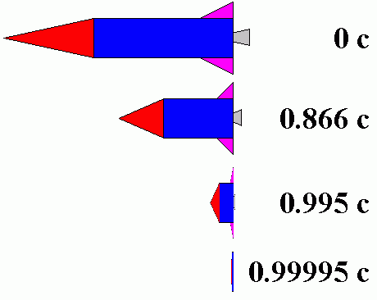
  - Again, all appears normal to the travelling observer.
  - Consider a rocket travelling at various velocities, from right to left as seen by a stationary observer.
  - According to the observer, the rocket gets smaller in the direction of travel – note that the thickness does not change.
  - If the rocket reaches the speed of light, the rocket will apparently have a length of 0.
  - According to the traveller, everything appears normal.

  - This effect is real, as is time dilation.

  - The expression for calculating the relativistic length is given by:

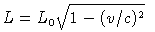
$$γ= \frac{1}{\sqrt{1- \frac{v^{2}}{c^{2}}}} β= \frac{v}{c}$$
- A space capsule of length exactly 1.0 m long is sent into space. An observer on one planet sees the capsule moving at a speed of 0.5 c and another observer on another planet sees the capsule moving at 0.99 c. What is the length of the capsule according to both observers?

- The capsule contains a puppy with supplies to last a long time. If the average speed of the capsule is calculated to be 2.25 x 10⁸ ms⁻¹, and the age of the puppy appears to be 7.00 years old when it returns to Earth, calculate the time that the capsule was travelling for according to observers on Earth.

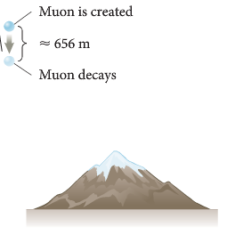
- Since time dilation occurs, two observers will measure time differently. It follows that distances travelled will also be measured differently.

- Consider a muon, 5 km above the Earth and travelling at 0.995 c. If it lasts for
2.2 x 10⁻⁶ s, it can be seen that it should travel about 660 m.
$$v= \frac{s}{t} so s=v x t=0.995 x 3 x {10}^{8} x 2.2 x {10}^{-6}=657 m$$

- Since muons reach the Earth, this must be incorrect.

- One explanation is that time for the muon must be dilated, as measured from someone on Earth.
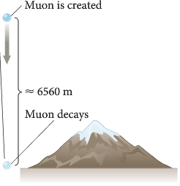
$t= \frac{t_{0}}{\sqrt{1-\frac{v^{2}}{c^{2}}}}=2.2 x {10}^{-5} s s=v x t=0.995 x 3 x {10}^{8} x 2.2 x {10}^{-5}=6567 m$

- Another consideration is that from the muons point of view, the length contracted.
$$l= l_{0} \sqrt{1- \frac{v^{2}}{c^{2}}}=499 m t= \frac{s}{v}= \frac{499}{0.995 c}=1.67 x {10}^{-6} s$$
- This is less than the decay time for the muon, so it will reach the Earth.

- The closest star to us (after the Sun) is Alpha Centauri. It is about 4.24 light years away. Deep Space 1 can travel at a maximum velocity of 56 000 km hr⁻¹. Show that it would take over 81 000 years to get to Alpha Centauri.

- In reality, the distance to Alpha Centauri would be contracted at this speed. Determine by how much, in light years.

- NASA has produced a study into Laser Sail propulsion that can accelerate a space craft to 0.5c in under a decade. At a speed of 0.5c, how long would it take to travel 4.24 ly?

- Calculate the distance contraction at this speed.

PP 8.3 p 325-9 8.3 Review p 329-30
- Composition of velocities:
  - Velocities (and speeds) do not simply 'add'.
  - For example, if a rocket is moving at 0.9 c relative to an observer, and the rocket fires a missile at 0.2 c relative to the rocket, the missile does not exceed the speed of light relative to the observer.

Velocity Transformations

- When two frames of reference have motion relative to each other, it is possible to determine the velocity of one object moving in one frame, as viewed by the other.
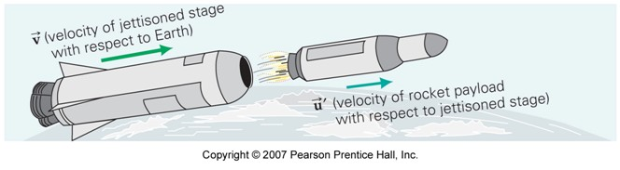
- The following equations can be used.
O

2
1

where u = velocity of object 2 relative to observer O.
u’ = velocity of the same object (2) as observed from object 1.
v = velocity of object 1 relative to observer O.
c = speed of light

- At low speeds, the value of $\frac{uv}{c^{2}}$ is close to zero.
- That is u = v + u’

- A man is watching two cars moving away from him. Car A is moving at 70 ms⁻¹ away from the man. Car B is moving away from A at a rate of 60 ms⁻¹. Car B is moving in the same direction but is in front of A. Determine the velocity of Car B as seen by the man.





B : 60 ms⁻¹
A : 70 ms⁻¹

- Consider the situation above where a payload is jettisoned from a rocket. If the rocket is travelling 0.60 c with respect to the observer on Earth and the second stage is travelling at 0.6 c with respect to the rocket (1), how fast is the rocket payload travelling according to the observer on Earth?

- A spaceship (A) is moving away from Earth at 0.70 c. Another spaceship (B) is travelling towards (A). As seen from Earth, spaceship (B) is also moving towards Earth at 0.50 c. Determine the velocity of spaceship B as seen by A.

Relativistic momentum increases at high relative speed and prevents an object from reaching the speed of light.
This includes applying the relationship

PP 8.4 p 334-6
- Inertia and momentum:
  - As an object's speed approaches the speed of light from an observer's point of view, its mass appears to increase thereby making it more and more difficult to accelerate it from within the observer's frame of reference.
  - Mass appears to dilate as well.
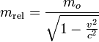

  - Mass and therefore momentum, reach infinity at the velocity of light.
  - Note that this would require infinite amounts of energy to achieve and thus further supports the light speed limit for matter!
$p= \frac{mv}{\sqrt{1- \frac{v^{2}}{c^{2}}}}$ $E= \frac{mc^{2}}{\sqrt{1- \frac{v^{2}}{c^{2}}}}$

- Why is it that a hot object is slightly more massive than when it is cold?

- An electron is placed into a magnetic field and accelerated to 0.95 c. Determine its relativistic momentum.

(MODULE 5)
http://www.phys.unsw.edu.au/einsteinlight/
PP 8.4 p 331-7 8.3 Review p 338
- In particle accelerators, particles moving at huge speeds will encounter mass increases.
  - For particles moving in a circular path it can be shown that

$$r= \frac{m v}{B q}$$

  - Normally, if if m, B and q are constant, then r depends on v.
  - However, the mass of an electron travelling at 0.9999999c will have a mass 6000 times greater than an electron at rest.
  - This needs to be taken into account in particle accelerators.

Speed of Light

- No object with mass can accelerate to precisely the speed of light.

- A massless object, like a photon, can move at the speed of light. (A photon doesn't actually accelerate, though, since it always moves exactly at the speed of light.)

- But for a physical object, the speed of light is a limit. The kinetic energy at the speed of light goes to infinity, so it can never be reached by acceleration.

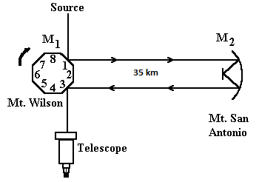
Measuring Speed of Light

- Light from a source is reflected from a spinning mirror, travels to another mirror 35 km away and returns. When the rotation of the spinning mirror reaches a certain level the light is seen in the telescope.

- If the mirror spins at 32 000 rpm, calculate the time for the mirror to rotate by 1/8th and then calculate the speed of light if it travels 35 km and back in this time.

frequency = 32 000 rpm = 533.3 rps

$1 spin= \frac{1}{533.3}=1.875 x {10}^{-3} s$ $v= \frac{s}{t}= \frac{2 x 35000}{2.344 x {10}^{-4}}=2.99 x {10}^{8} ms^{-1}$

$$\frac{1}{8^{th}} spin= 2.344 x {10}^{-4} s$$

PP Chapter review p 339-40 Unit 4 Review Questions p 386-9

Websites to Work Through:
Work through the following websites to further enhance your understanding of this section.
http://www.phys.unsw.edu.au/einsteinlight/
http://www.anu.edu.au/Physics/Savage/TEE/site/tee/learn.html
http://www.teachersdomain.org/resource/phy03.sci.phys.energy.sprelativity/
http://www.squidoo.com/relativity_explanation

EP p178-92 Prob Set 14.1 p196, Prob Set 14.2 p198

Answers p20

Question 20 (2 marks)
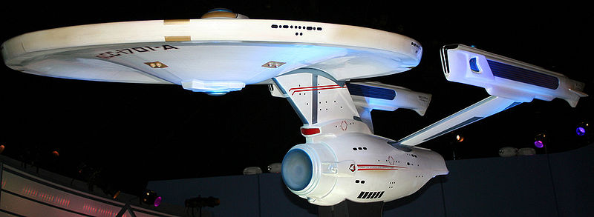
http://commons.wikimedia.org/wiki/File:Enterprise_NCC-1701-A.jpg

In the science fiction TV series Star Trek, the starship Enterprise is accelerated to speed faster than the speed of light (“warp speed”) for travel between star systems or galaxies. Explain why is it impossible to travel at or faster than the speed of light?

Question 21 (2 marks)
Two identical atomic clocks of extreme accuracy are set to within the same nanosecond at Greenwich in England. One of the clocks is then flown to Perth at 800 km h⁻¹. In Perth the clock is now several nanoseconds different to its “twin” still at Greenwich.

- Is the clock in Perth ahead or behind its “twin”? (1 mark)

- What has caused this difference in time? (1 mark)

Question 22 (5 marks)
In the science fiction series Star Trek, Captain Kirk orders the starship Enterprise to travel from Earth on a rescue mission to Alpha Centauri (4.2 light-years away). Due to battle damage, the fastest speed that the Enterprise can travel at is just below the speed of light. The crew includes twins and while one of two identical twins is on the mission to Alpha Centauri the other remains on Earth.

- The Enterprise can only manage a speed of 0.98c (c = speed of light). At this speed, how long will the starship take to travel to Alpha Centauri and return as seen from Earth? (1 mark)

- The time dilation equation is
√
t .
v²

1 –
t₀ =
c²

where t₀ is the apparent time elapsed on the starship and t is the actual time taken for the trip.
For the crew on board, what appears to be the time taken to travel to Alpha Centauri and return? (2 marks)

- On the return to Earth the twins are no longer the same age, one is older.
Which twin has aged more and by how much? (2 marks)

Question 23 (7 marks)
The following graph shows the factor by which mass increases with increasing velocity approaching the speed of light.
Mass increase
v/c
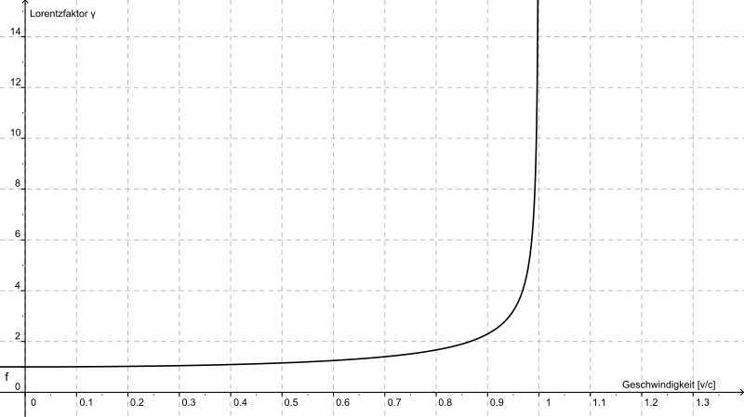
http://commons.wikimedia.org/wiki/File:Lorentzfaktor.svg

A proton of mass 1.67 x 10⁻²⁷ kg is accelerated in the Large Hadron Collider until it reaches 0.95c
(c = speed of light).

- Estimate the new mass of the proton from the graph. (2 marks)

- What is the reason for this apparent increase in mass? (1 mark)

(1 mark)

Einstein derived the mathematical equation showing how mass changes with speed.

where m₀ is the rest mass and m_{v} is the mass when moving (in kg).

- Using the equation above, calculate the mass of the proton when it is moving at 0.99c.
(2 marks)

- Why is it impossible for the proton to travel at or faster than the speed of light? (2 marks)

Question 24 (3 marks)
Adventure parks have developed rides that simulate the real adventure for their customers. Patrons sit in chairs in the dark and watch a projected computer image of a high speed chase. Every turn, dive and twist appears real as the seat appears to lurches, but in fact it is stationary. The virtual reality ride appears very realistic.

Why does it seem as if you are actually in a chase?

Question 25 (2 marks)
A freelance motoring journalist was caught speeding in a $470,000 imported Italian car at
231 km h⁻¹ during a test drive in a 110 km h⁻¹ zone.

- A police car coming in the opposite direction at 110 km h⁻¹ recorded his speed on its radar. What was the closing speed of the cars as they approached each other? (1 mark)

- If the police car was following the Italian car at 110 km h⁻¹, what speed would it register on the radar? (1 mark)

Question 26 (2 marks)
The Andromeda galaxy is receding from Earth at about 0.3c (c = speed of light).

In the search for extraterrestrial life, a radio signal is sent from Earth into space. At what speed is the radio signal received on Andromeda? Explain your answer.

Question 27 (3 marks)
In 1983, a Korean Airlines 747 airliner that strayed into Russian airspace (due to computer navigational errors) was shot down. Since 1994, 24 satellites in orbit have allowed positions on Earth to be accurately known to within 15 metres. Orbiting at an altitude of 20 200 kilometres, about 10 satellites are visible to the ground-based receiver. Each satellite continually transmits messages which include the time the message was sent. The receiver measures the time of each message from the satellites and computes the distance to each satellite.

To work correctly, the clocks on the satellites and the clock in the receiver must be set identically. The clocks are extremely accurate, relying on vibrating quartz crystals to keep the time. Over a period of exactly 24 hours the total time difference between the clock in the orbiting satellite and the clock in the GPS receiver is 3.8 x 10⁻⁵ s.

- What could cause the difference in time? (1 mark)

- Which clock runs faster? (1 mark)

- What absolute error would there be in the measurement of the distance to a GPS receiver from a satellite directly overhead after 24 hours, if the clock is not corrected? (2 marks)

Extension and Discussion questions

Question E7 (3 marks)
A Klingon battleship passes by the stationary starship Enterprise at 0.92c. To the crew on the Enterprise, the Klingon vessel appears

- longer/ shorter/ the same as its known length of 500m. (1 mark)

Using the equation
_______
L = L₀ √ 1 – v²
c²

where L is the observed length and L₀ is the actual length

- calculate the length of the Klingon battleship as it appears to the crew on the Enterprise.
(2 marks)

Question E8 (7 marks)
Muons are formed when cosmic radiation impacts air molecules 10 km up in the Earth’s atmosphere. About 10 000 muons reach every square meter of the Earth’s surface every minute. The mean lifetime of a stationary muon is 2.2 x 10⁻⁶ seconds before it decays. Muons travel at speeds of up to 0.999c and can penetrate deep into rock. They are detectable deep underground and underwater.

Rossi and Hall in 1940 were able to “prove” the effect of time dilation on high speed muons. They measured muon impacts on a scintillation counter at an altitude of 3000 metres (568 counts h⁻¹) and at sea level (412 counts h⁻¹).

- What distance would a muon be expected to travel in its mean lifetime? (Not including any special relativity effects) (1 mark)

- Using the information from (a) would you expect many muons to reach the Earth’s surface from where they were formed? (1 mark)

- Using the equation below, calculate the mean lifetime of a muon in its own (moving) frame of reference. (2 marks)
_______
t₀ = t. √ 1 – v²
c² where t₀ is the actual time and t is the apparent time.

- How far will a muon move in its mean lifetime taking into account special relativity? (1 mark)

- Would you now expect more muons to reach the Earth’s surface? Explain. (1 mark)

- How did the data collected by Hall and Rossi “prove” time dilation actually exists? (1 mark)

Question 20 (2 marks)

As the velocity of particles approach the speed of light, energy is required to increase the velocity further. Some of this energy is turned into mass requiring even larger amounts of energy to accelerate.
(1 mark)

No particle can reach the speed of light as it will gain mass according to the Einstein equation
E = mc².
(1 mark)

Question 21 (2 marks)

- Is the clock in Perth ahead or behind its “twin”? (1 mark)
Behind
- What has caused this difference in time? (1 mark)
According to Einstein’s theory of special relativity, time passage slows for a moving object.
(1 mark)

Question 22 (5 marks)

- The Enterprise can only manage a speed of 0.98c (c = speed of light). At this speed, how long will the starship take to travel to Alpha Centauri and return as seen from Earth? (1 mark)

At 0.98c 8.4 ÷ 0.98 = 8.572 years
- The time dilation equation is

t₀ = 8.572 √ 1 – (0.98c)²
c²
(1 mark)
= 1.706 years
(1 mark)
- On the return to Earth the twins are no longer the same age, one is older.
Which twin has aged more and by how much? (2 marks)

The Earth twin is older.
(1 mark)
The age difference is 8.572 – 1.706 = 6.866 years.
(1 mark)

Question 23 (7 marks)

- Estimate the new mass of the proton from the graph. (2 marks)

From graph mass increases roughly by 3X
(1 mark)
1.67 x 10⁻²⁷ x 3 = 5.01 x 10⁻²⁷ kg
(1 mark)

- What is the reason for this apparent increase in mass? (1 mark)
Some of energy being put into proton to accelerate causes a mass increase E = mc².
(1 mark)

- Using the equation above, calculate the mass of the proton when it is moving at 0.99c.
(2 marks)

(1 mark)
= 1.67 x 10⁻²⁷
0.141

= 1.18 x 10⁻²⁶ kg or about a 7X increase.

- Why is it impossible for the proton to travel at or faster than the speed of light? (2 marks)
The proton cannot be accelerated to the speed of light its mass approaches infinity, this
would require and infinitely large force to accelerate the proton.

Question 24 (3 marks)
In the dark cannot see the other chairs. (1 mark)
The only frame of reference (1 mark)
is the screen which appears to be moving. (1 mark)

Question 25 (2 marks)
- A police car coming in the opposite direction at 110 km h⁻¹ recorded his speed on its radar. What was the closing speed of the cars as they approached each other? (1 mark)
110 + 231 = 341 km h⁻¹

- If the police car was following the Italian car at 110 km h⁻¹, what speed would it register on the radar? (1 mark)

231 – 110 = 121 km h⁻¹

Question 26 (2 marks)
Arrives traveling at 3 x 10⁸ m s⁻¹
(1 mark)
According to Einstein’s theory of special relativity the speed of light in a vacuum is constant no matter what is the frame of reference.

(1 mark)

Question 27 (3 marks)
- What could cause the difference in time? (1 mark)
The clock on board the satellite is moving.
- Which clock runs faster? (1 mark)
Clock on Earth runs faster.
- What absolute error would there be in the measurement of the distance to a GPS receiver from a satellite directly overhead after 24 hours, if the clock is not corrected? (2 marks)

Error = 0.000038 x 3 x 10⁸ = 11400 m

Question E7 (3 marks)

- longer/ shorter/ the same as its known length of 500m. (1 mark)

shorter
- calculate the length of the Klingon battleship as it appears to the crew on the Enterprise.
(2 marks)
L = L₀ √ 1 – v²
c²
where L is the observed length and L₀ is the actual length,

L = L₀ √ 1 – v²
c²
$L= 500\sqrt{1-(\frac{(0.92c))^{2}}{c^{2}})}$ (1 mark)
= 500 x 0.3919
= 195.9 m
(1 mark)

Question E8 (7 marks)
- What distance would a muon be expected to travel in its mean lifetime? (Not including any special relativity effects) (1 mark)

s = v x t
= 2.2 x 10⁻⁶ x 0.999 x 3 x 10⁸
= 660 m
(1 mark)
- Using the information from (a) would you expect many muons to reach the Earth’s surface from where they were formed? (1 mark)
If the average muon only travels 660 m then few will travel from the upper atmosphere to the Earth’s surface.

- Using the equation below, calculate the mean lifetime of a muon in its own (moving) frame of reference. (2 marks)
2.2 x 10⁻⁶ = t . √ 1 – (0.999c)²
c²
(1 mark)
t = 4.92 x 10⁻⁵ seconds is mean lifetime as seen by the muon itself.
(1 mark)

- How far will a muon move in its mean lifetime taking into account special relativity? (1 mark)

s = v x t
= 0.999 x 3 x 10⁸ x 4.92 x 10⁻⁵
= 14745 m
(1 mark)
- Would you now expect more muons to reach the Earth’s surface? Explain. (1 mark)

Say from 3000 m where there are considerable muons – yes.

- How did the data collected by Hall and Rossi “prove” time dilation actually exists? (1 mark)

Muons “live” longer and this explains why they are recorded deep below ground.

